Scottish Rugby Club Tickets – 2023 Guinness Six Nations
MEMBERS APPLICATION
To be completed by individual club members and returned to ticket secretaries.

To apply for international match tickets, you must have an online ticketing account with Scottish Rugby.
Match tickets will be emailed to you, therefore, if you do not have an account, please visit scottishrugbytickets.com and register now.
Please ensure the below details are completed in full before submission.

Club member’s details

First Name | ( | Surname
Scottish Rugby e-ticketing client reference
(This can be found by logging in to your account. The client reference can be found by clicking ‘My Account’.)
Email
Telephone | Landline: |  | Mobile:

Pricing & Fixtures

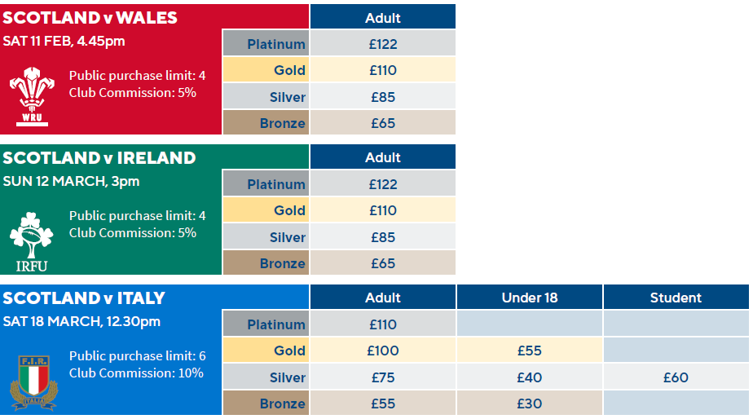

Club Order & Payment Process

As of season 2021/22 you will pay for your tickets through your online ticketing account.
You will continue to order via your secretary and will receive an email once your tickets are ready for payment.
Once logged into the ticketing site, you can select whether your tickets are Adult, Under 18 or Student. Full video guidance and FAQs are available at ask.scottishrugby.org

Your Ticket Order

Scotland v Wales | Sat 11 Feb 2023, Kick Off 4:45pm | Platinum | Gold | Silver | Bronze
Quantity:
*No concession pricing available

Scotland v Ireland | Sun 12 Mar 2023, Kick Off 3:00pm | Platinum | Gold | Silver | Bronze
Quantity:
*No concession pricing available

Scotland v Italy | Sat 18 Mar 2023, Kick Off 12:30pm | Platinum | Gold | Silver | Bronze
Quantity:

Transactions Fees
Scottish Rugby will apply a non-refundable booking fee per ticket to cover the overheads associated with the processing and issuing of tickets.
These fees will be added to your booking at the point of payment and will be £1.00 per ticket. Please see ‘Next Steps’ for further information relating to paying for your ticket order.

Next Steps

Step 1: Please return this completed form to your Club Ticket Secretary by the deadlines communicated.

Step 2: Your Club Ticket Secretary will allocate your ticket using our club ticket allocation portal.

Step 3: You will receive an email notification inviting you to make payment for your order. Once logged into your ticketing account you can add these tickets to your basket and select whether your tickets are Adult, under 18 or Student (if categories are available). Please follow the instructions and make payment for your ticket order.

Step 4: Delivery of tickets can be as close to 2 weeks before the match. If for some reason you don’t receive your email with your match tickets, contact ticket.centre@sru.org.uk

Full instructions on how to complete payment for your transaction can be found here: https://ask.scottishrugby.org/hc/en-gb/articles/360021489579-Club-Tickets-Member-Instructions

Ticketing Terms & Conditions
The application, allocation, purchase, use, sale or transfer of tickets to Scotland’s home international rugby fixtures is subject to Scottish Rugby’s Ticketing Terms & Conditions which are available at https://www.scottishrugby.org/tickets-and-events/tickets-terms-and-conditions
By applying for, using or purchasing tickets through the Scottish Rugby Club Ticket application process you hereby confirm that you have read and understood Scottish Rugby’s Ticketing Terms & Conditions and agree to be bound by them.
Without limiting any other remedies available, if you have breached (or in breach of) the Scottish Rugby Ticketing Terms & Conditions, Scottish Rugby shall be entitled to refuse entry, cancel, confiscate or de-activate the ticket and exclude you from purchasing future tickets.

Personal Information
By applying for, purchasing and/or using a ticket, you confirm that any personal information you provide is accurate and up to date and you agree that Scottish Rugby Union Limited will collect and process your personal information in accordance with its Privacy Policy which is available at www.scottishrugby.org/privacy-policy

Declaration
I confirm that I have read and accept Scottish Rugby’s Ticketing Terms & Conditions and that the information I have provided is accurate and up to date.
Full Name
Sign |  | Date

